


Infodraw PMRS-102 Ruggedize Media Relay System
Product Specification

Overview
PMRS-102 Ruggedize is a smart, small, handheld metal IP-65, wearable streaming media system from the field over cellular network. It allows to stream video/audio/location live and monitoring video, audio and location over map anywhere upon alarm/request.

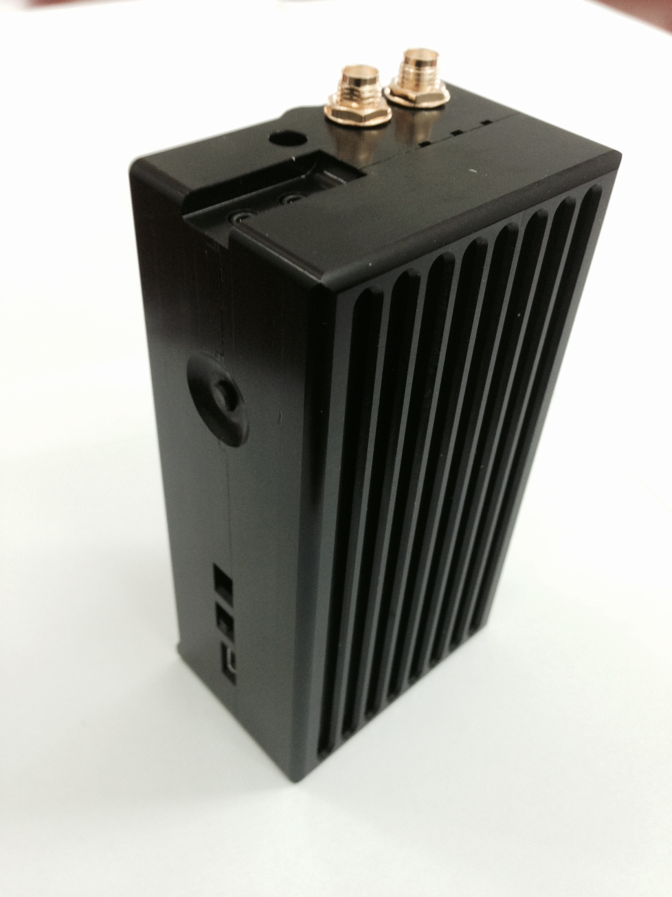
Key Features
- Handheld, wearable small form factor

- Real embedded system (design for cellular network)
- Live video/audio/location streaming (low latency)
- Dual encoding (recording and streaming)
- Dual resolution for recording/streaming D1/CIF accordingly
- PTZ control using RS-485
- Built-in cellular module (need only SIM)
- Built-in memory for local recording (128MB)
- Micro SD slot for local recording (up to SDHC 32g)
- Optional Encryption (RSA 1024+AES)
- High performance DSP based CODEC (H.264)
- 1 Analog video input CIF/D1
- 1 video over IP
- 1 audio over IP (2 ways)
- Built-in GPS receiver
- Deep Sleep mode and scheduler (months) using battery only
- Monitoring video/voice and location over map
- Tracking history over map
- Bit rate/Frame rate remote control
- Automatic bandwidth control
- Alarm push button
- Motion detection
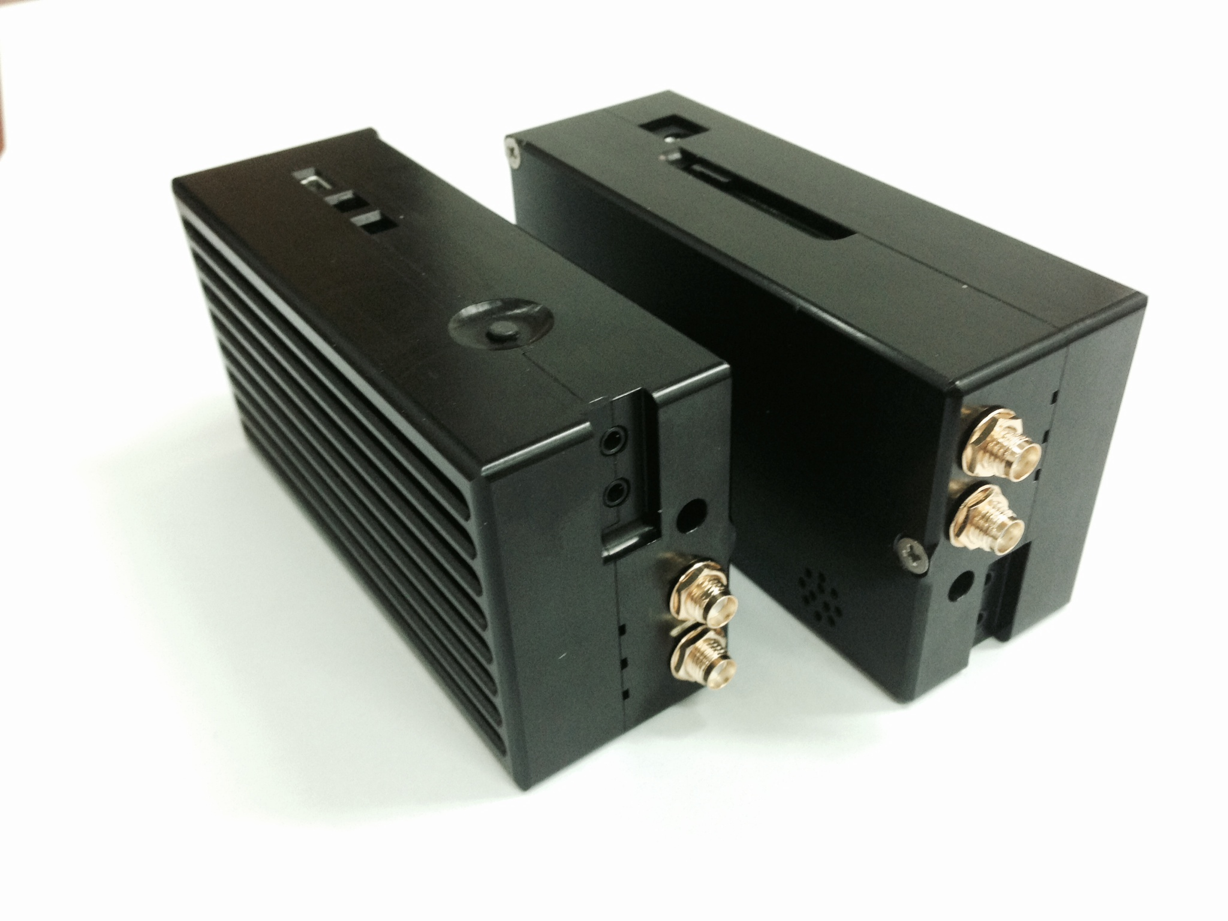
- SMS send according to events
- Built-in lithium battery 10Ah (10 hours streaming)
- Very low power 0.5 Amp while streaming (5v)
- Built-in 5v output to camera
- Recording on remote monitoring
- Web streaming using flash client
- Permission capability for different access level
- Upgrade firmware on the fly
- Small form factor 6.5 X 12 X 4 cm
- Built-in LAN interface
- Support iPhone and Android phone clients

Technical Specifications

Video
Video Input | 2.5 mm video/audio/power 5v plug | PAL/NTSC
Video compression | H.264 Dual encoding (streaming/recording) | CIF/D1
Bit rate | From 10kbs to 2Mbs
Frame rate | Up to 25/30
PTZ Control | Built-in RS-485 (T+, T-)
Audio
Audio Input | Built-in microphone or Line in
Audio output | Line out
Audio compression | AAC
GSM
GSM | Built-in (need only SIM) | HSPA/3G/EDGE/GPRS
Antenna | Built-in
Bandwidth control | Automatic
GPS
GPS | Built-in | Update every few sec
Antenna | External
Alarm Button
Push button | On surface
Memory
Micro SD | Slot (max bit rate according to micro SD write speed) | Up to 32g
I/O
4 Input/4 output | Built-in Through cable interface | Dry contact
Power
Power Input | 5V | AC/DC to 5V adapters
Power consumption | 500mA while streaming
Battery Lithium | Built-in 10Ah (10 hours streaming)
Power output | 5v output to camera
Environment
Water proof | IP-65
Temperature Input | -10 +70
Physical
Dimension | 6.5 x 12 x 4 cm
Weight | 200 gr
Other Interfaces
USB client | Built-in | For Setup
video/audio/power cable | Splitter cable with RCA, audio, 5V power
Earphone/mic cable
LAN | 10/100 Built-in Through cable interface
Protocols
RTP/RTSP/SDP

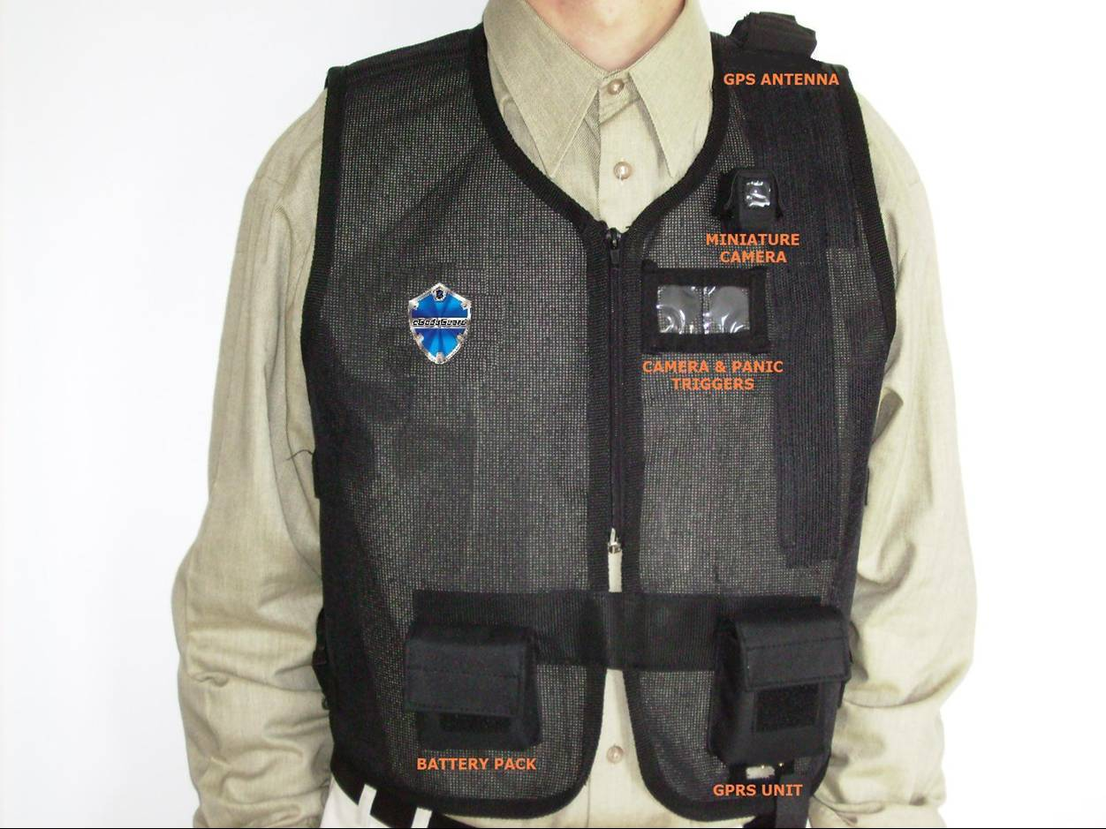
PMRS-102 System Advantages:

- Handheld, wearable small form factor
- MRS architecture is based on MRS server
- Units can stream with the highest bandwidth exist
regardless number of clients
- Dual encoding (local recording in D1 and streaming in CIF is possible)
- System design for low bandwidth and packet delivery failure
- Automatic bandwidth control by the units
- Multi clients to multi units communication using the server
- Only MRS server must have fix IP address
- Live video, voice and location over map are combine together in one monitoring application
- Built-in cellular module (need only SIM)
- Deep Sleep mode and scheduler (remote control)

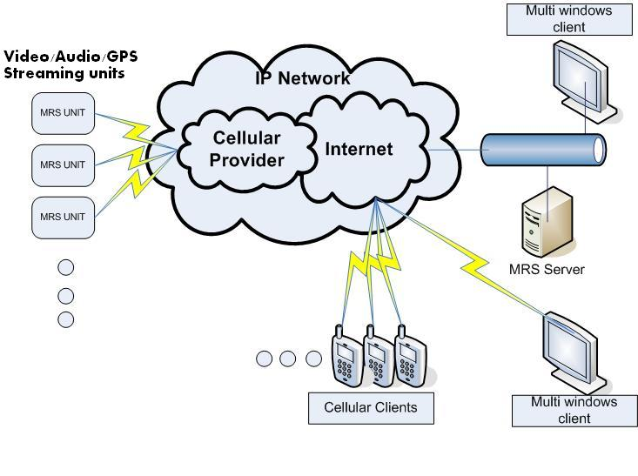

Figure 1- MRS System Architecture

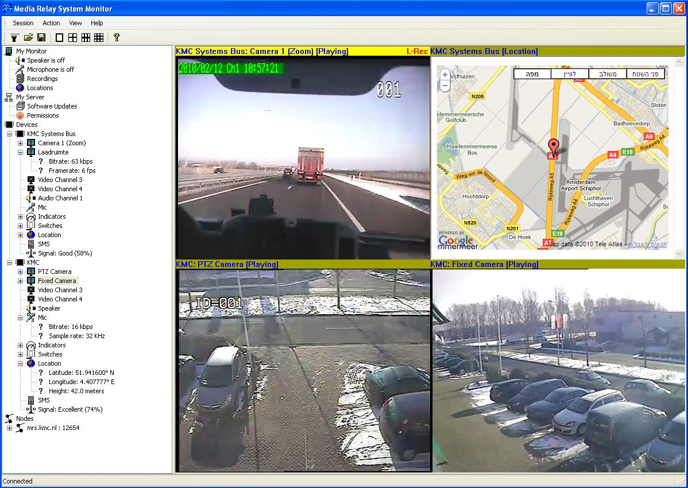

Figure 2- MRS Demo monitoring

